**Creating producer and consumer Kafka Application Using Java Program to send Java object like employee**

Spring boot with Apache Kafka

Producer

Web starter,

Kafka Kafka Starter : This starter provide KafkaTemplate API which help to send the data.

We need do kafka related configuration in application.properties files

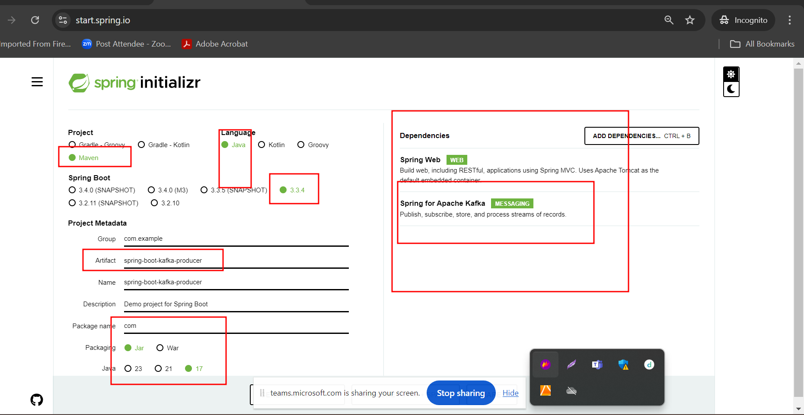

Consumer

@KafkaListener : generally we write this annotation on a method part service layer. It will ask use topic name and group id and configuration we need to write in application.properites file. Whenever any message send by producer this method fired the event retrieve the information. Once you get the data. We can do some operation on those data.

